CS 255 System Design Document Template

UML Diagrams

UML Use Case Diagram

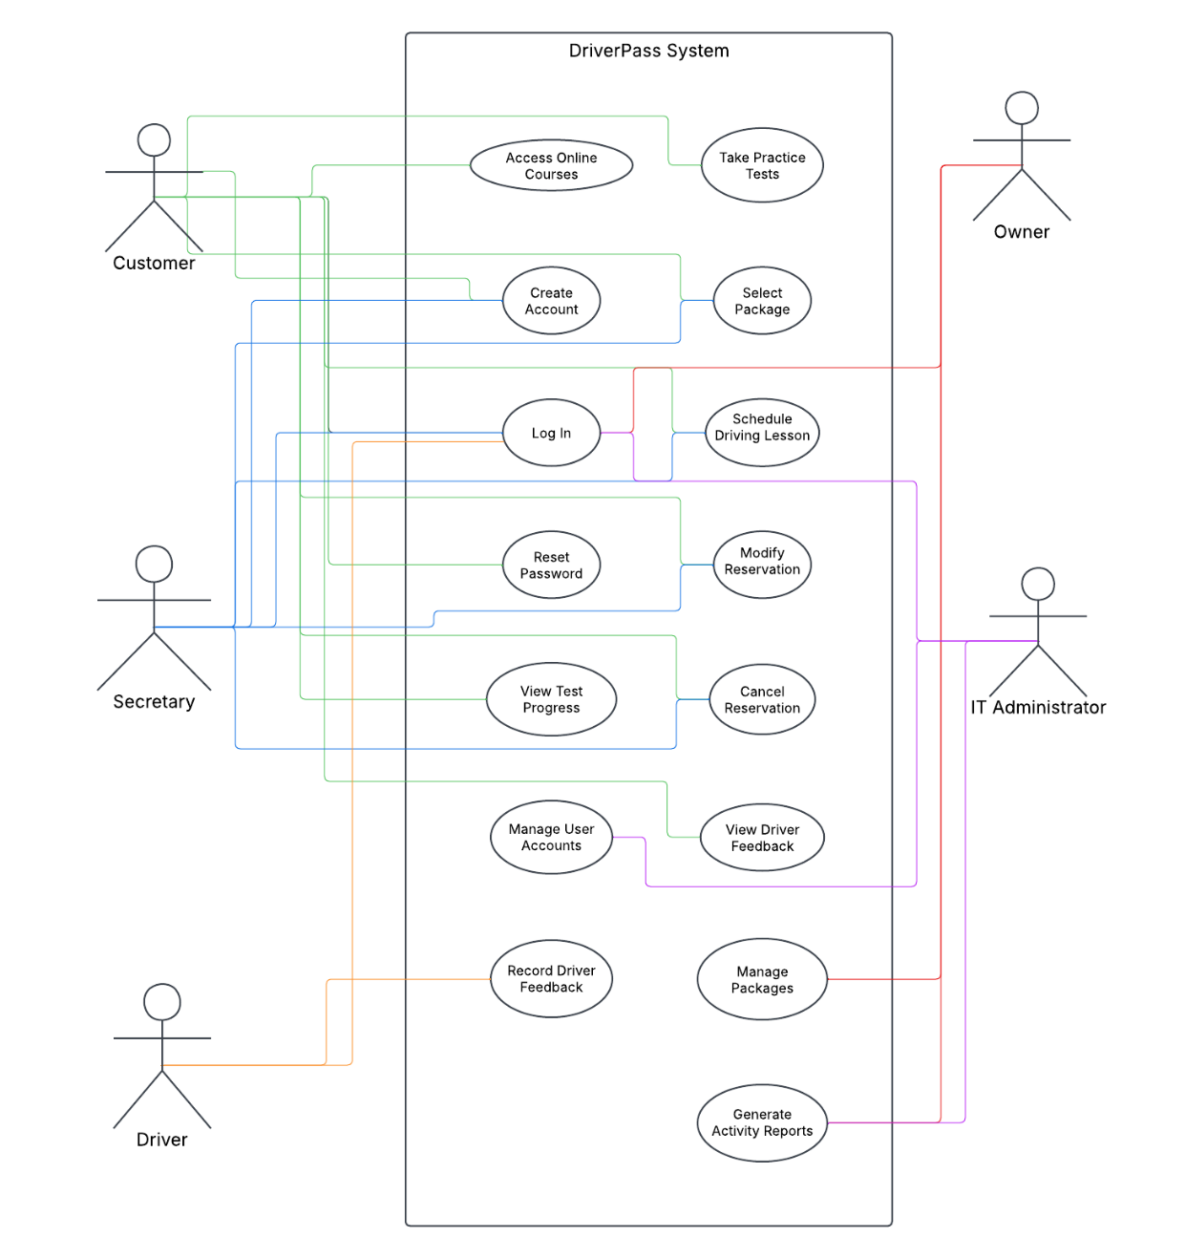

UML Activity Diagrams

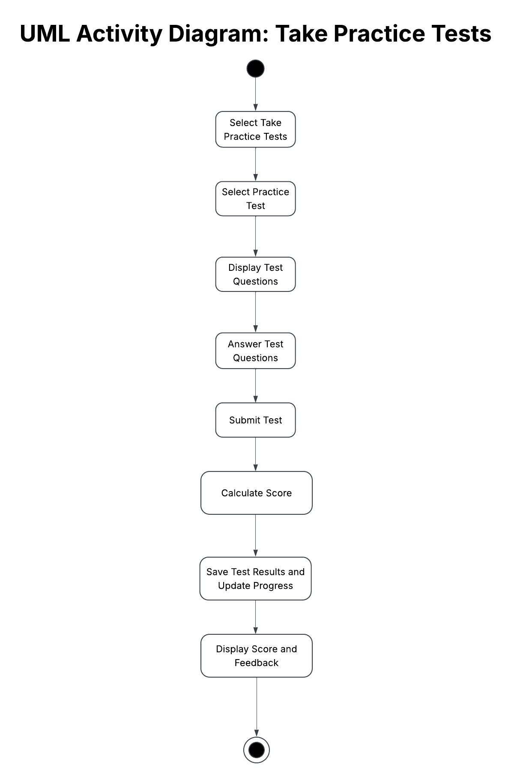
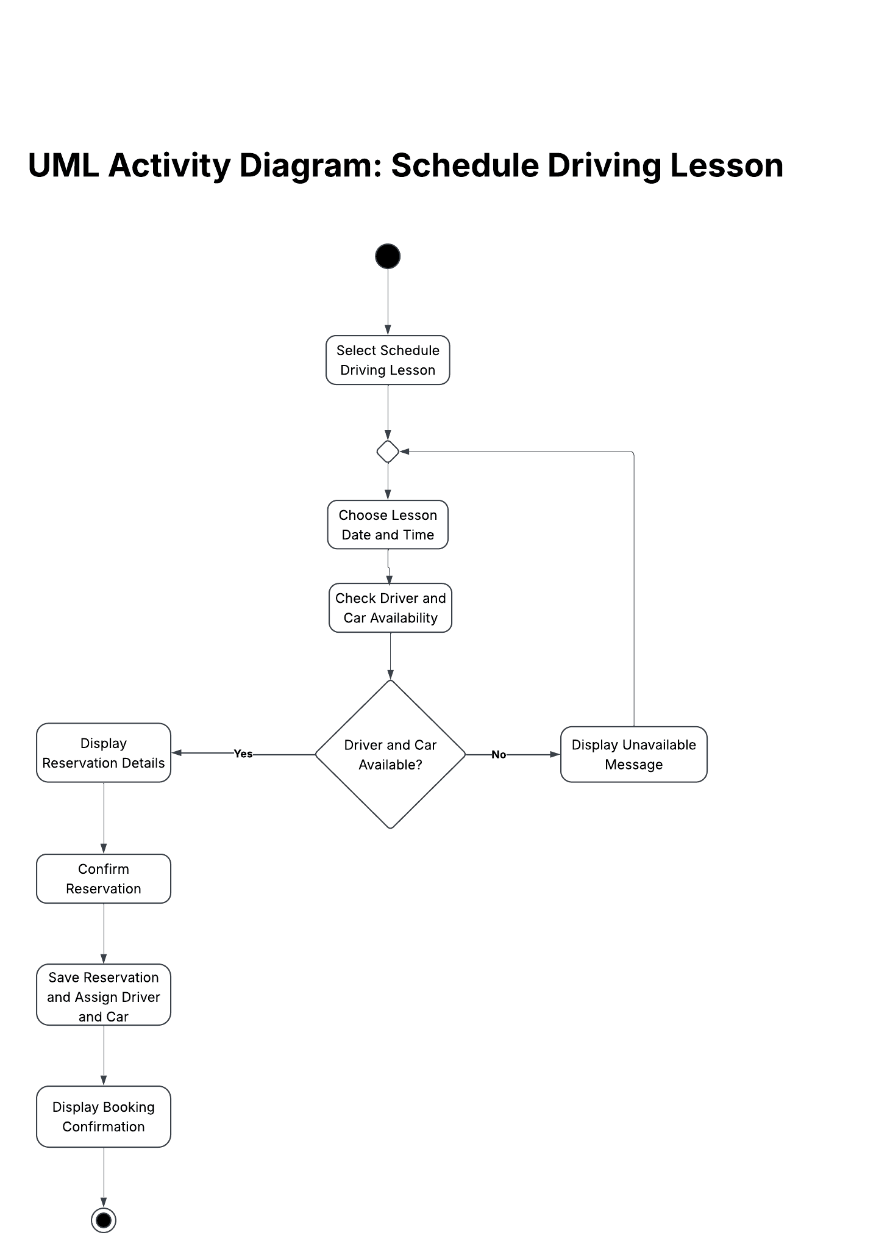

UML Sequence Diagram

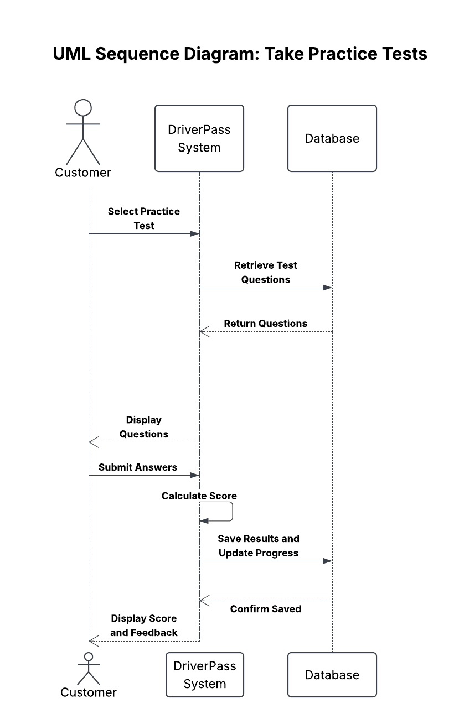

UML Class Diagram

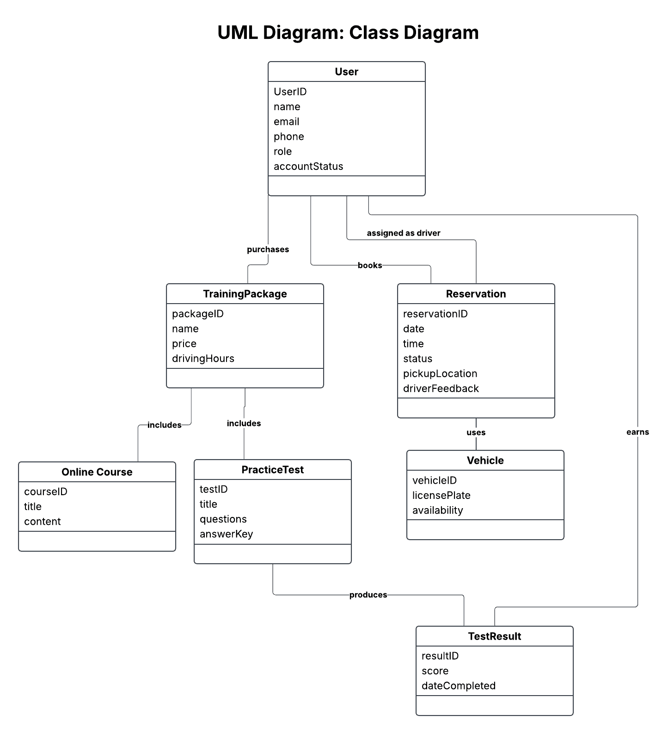

Technical Requirements
The system needs to run on the web on either a computer or mobile device. The system will use cloud servers for its database. The software requirements are web browser to access the application and database management to store and retrieve data. The system will require backup tools to protect stored data. The system infrastructure will require cloud hosting for the application and database as well as for backups. The system site will use HTTPS to encrypt the data that is sent and received.

